DETECTING AND DIAGNOSING BRAIN TUMORS USING ML

PROJECT REPORT

Submitted in partial fulfillment of the requirements for the award of the degree of

BACHELOR OF TECHNOLOGY
in

COMPUTER SCIENCE AND ENGINEERING

Submitted by
SHAIK. AJITH  Roll No. 21731A05C1 |  | MAVILLA. BHARGAV  Roll No. 21731A05A1
GADAMSETTY. HARICHANDAN  Roll No. 21731A05E1 |  | LAKKAKULA. JAYA SANKAR  Roll No. 21731A0596

Under The Guidance of

Ms. Guna Gayathri Praseetha K


Assistant Professor

DEPARTMENT OF

COMPUTER SCIENCE AND ENGINEERING

PBR VISVODAYA INSTITUE OF TECHNOLOGY & SCIENCE

(AUTONOMOUS)

KAVALI-524201, NELLORE DISTRICT, AP

(Affiliated to J.N.T.U.A, Approved by AICTE and Accredited by NAAC)

APRIL 2025

PBR VISVODAYA INSTITUTE OF TECHNOLGY & SCIENCE
(AUTONOMOUS)
KAVALI

BONAFIDE CERTIFICATE

Certified that this project report “DETECTING AND DIAGNOSING BRAIN TUMORS USING ML” is the Bonafide work done by “SK.Ajith (21731A05C1), G.Harichandan (21731A05E1), M.Bhargav (21731A05A1), L.Jaya Sankar (21731A0596)”, who carried out the project under my guidance during the year 2024-2025, towards partial fulfillment of the requirements of the Degree of Bachelor of Technology in Computer Science & Engineering from Jawaharlal Nehru Technological University Anantapur. The results embodied in this report have not been submitted to any other University for the award of any degree.

Ms. Guna Gayathri Praseetha K Dr. G. VIJAY KUMAR

PROJECT SUPERVISOR HEAD OF THE DEPARTMENT
DEPARTMENT OF C.S.E. DEPARTMENT OF C.S.E.

External Viva voce conducted on -------------------------------------

INTERNAL EXAMINER EXTERNAL EXAMINER

PBR VISVODAYA INSTITUTE OF TECHNOLOGY & SCIENCE
KAVALI

CERTIFICATE OF AUTHENTICATION

We solemnly declare that this project report “DETECTING AND DIAGNOSING BRAIN TUMORS USING ML” is the bonafide work done purely by us, carried out under the supervision of Ms. GUNA GAYATHRI PRASEETHA K, Assistant Professor towards partial fulfillment of the requirements of the Degree of BACHELOR OF TECHNOLOGY in Computer Science & Engineering from Jawaharlal Nehru Technological University Anantapur during the year 2021-2025.

It is further certified that this work has not been submitted, either in part of in full, to any other department of the PBR Visvodaya Institute of Technology and Science, or any other University, institution or elsewhere, or for publication in any form.

DATE: SIGNATURE OF THE STUDENTS

SK. AJITH (21731A05C1)

G. HARICHANDAN (21731A05E1)

M. BHARGAV (21731A05A1)

L. JAYA SANKAR (21731A0596)

ACKNOWLEDGEMENT

We extend our heartfelt gratitude to Jawaharlal Nehru Technological University Anantapur, for providing us with the opportunity to complete this project report.

We express our deep appreciation and indebtedness to our esteemed Chairman,

Mr. D. VIDYADHARA KUMAR REDDY, Academic Director Dr. D. PRATHYUSHA REDDI and Academic In-Charge Dr. D. LIKHITH REDDY, for fostering an excellent academic environment.

It is our privilege to convey our sincere gratitude to our Director, Wg. Cdr. I.P.C. Reddy (Retd.), and Principal, Dr. N. SESHAIAH, for granting us this opportunity to successfully complete our project report.

We are profoundly grateful to our Head of the Department, Dr. G. VIJAY KUMAR, Head & Professor, Department of Computer Science and Engineering, for his invaluable support, essential facilities, guidance, and unwavering encouragement, which played a crucial role in the timely completion of this project.

A special note of appreciation goes to our dedicated guide, Ms. GUNA GAYATHRI PRASEETHA K, Assistant Professor, for his inspiring mentorship, continuous encouragement, and insightful guidance throughout this project.

Lastly, we express our sincere gratitude to all our lecturers, lab coordinators, non-teaching staff, and friends who directly or indirectly contributed to the successful completion of this project, offering valuable suggestions and support at every step.

ABSTRACT

Brain tumors are one of the most critical health concerns, requiring timely detection and treatment for better survival rates. Traditional diagnostic methods rely on manual MRI scan analysis, which can be time-consuming and prone to human error. This project presents an automated Brain Tumor Detection and Medicine Suggestion System using Convolutional Neural Networks (CNNs) to classify MRI scans as "Tumor Detected" or "No Tumor Detected". The system aims to accelerate and enhance the accuracy of brain tumor diagnosis, supporting healthcare professionals in the early identification and management of this life-threatening condition.

TABLE OF CONTENTS
CHAPTER NO. |  | TITLE |  | PAGE NO.
 |  | List of tables |  | i
 |  | List of figures |  | ii
1 |  | Introduction |  | 1
 | 1.1 | Introduction to the project |  | 1
 | 1.2 | Objectives |  | 1
 | 1.3 | Existing System |  | 2
 |  | 1.3.1 Disadvantage of Existing System |  | 2
 | 1.4 | Proposed System |  | 2
 |  | 1.4.1 Advantages of Proposed System |  | 2
2 |  | System Requirements |  | 4
 | 2.1 | Software requirements |  | 4
 | 2.2 | Hardware requirements |  | 5
3 |  | System Analysis |  | 6
 | 3.1 | Architecture |  | 6
 | 3.2 | Methodology |  | 7
 | 3.3 | Hardware configuration |  | 9
4 |  | System Design |  | 10
 | 4.1 | Introduction |  | 10
 | 4.2 | UML Diagrams |  | 11
 |  | 4.2.1 Use Case Diagram |  | 12
 |  | 4.2.2 Class Diagram |  | 13
 |  | 4.2.3 Sequence Diagram  4.2.4 Activity Diagram |  | 14  15
5 |  | System Implementation |  | 19
 | 5.1 | Implementation |  | 19
 | 5.2 | Source code |  | 21
 | 5.3 | Output |  | 47
6 |  | System Testing |  | 52
 | 6.1 | Types of Testing |  | 52
 | 6.2 | Test cases and Results |  | 55
7 |  | Conclusion & Future Enhancement |  | 56
 | 7.1 | Conclusion |  | 56
 | 7.2 | Future scope |  | 56

8 |  | References |  | 58

LIST OF TABLES

TABLE NO. TABLE NAME PAGE NO.
6.2 Test Cases 55

LIST OF FIGURES

S.NO | FIGURE | PAGE NO
3.1 System Architecture 6

3.2.2 Data Flow Diagram 8

4.2.1 Use Case Diagram 12

4.2.2 Class Diagram 13

4.2.3 Sequence Diagram 14

4.2.4 Activity Diagram 15

4.2.5 Collaboration Diagram 16

4.2.6 Component Diagram 17

4.2.7 Deployment Diagram 18

6.1 Static Testing 53

Chapter: 1 1. INTRODUCTION

  - INTRODUCTION TO PROJECT
Brain tumors are abnormal growths of cells in the brain, which can be life-threatening if not diagnosed and treated in time. Early detection plays a crucial role in increasing survival rates. This project leverages deep learning techniques, computer vision, and web-based technologies to develop a system that predicts the presence of brain tumors using MRI images. The system integrates Flask as the backend framework, TensorFlow/Keras for deep learning model implementation, OpenCV for image processing, and SQLite for user authentication. It also features an email notification system to provide users with their diagnostic results. Additionally, it suggests medicines based on tumor size and locates the nearest hospital if medical attention is required.

1.2 OBJECTIVES
The proposed system leverages Convolutional Neural Networks (CNNs) to accurately classify MRI images and detect brain tumors, ensuring efficient and reliable diagnosis. It features a user-friendly web interface, allowing users to upload MRI scans and receive instant predictions regarding the presence of tumors. Based on the severity of the detected tumor, the system suggests appropriate medications or directs users to the nearest hospital for further medical assistance.

1.3 EXISTING SYSTEM
The existing system for brain tumor detection utilizes Support Vector Machine (SVM) for classifying MRI images into tumor and non-tumor categories. It processes MRI scans and applies feature extraction techniques to identify patterns associated with tumors. The system provides a basic interface where users can upload MRI images and receive classification results based on the trained model. It primarily focuses on detecting the presence of a tumor but does not extend to determining additional factors such as tumor size or providing further medical assistance. The approach ensures a structured and automated way to analyze MRI scans, reducing manual effort in preliminary diagnosis. However, it remains focused solely on classification without additional functionalities like location-based hospital recommendations or real-time alerts.

1.3.1 DISADVANTAGES OF EXISTING SYSTEM

The existing system for brain tumor detection utilizes Support Vector Machine (SVM) for classification instead of Convolutional Neural Networks (CNNs), allowing users to upload MRI images for analysis. However, it has several limitations, including the lack of tumor size detection, which prevents users from assessing the severity and progression of the tumor. Additionally, the system does not include a hospital locator feature, making it difficult for users to find nearby medical facilities for further diagnosis and treatment. The use of SVM instead of CNN also results in lower accuracy, as SVM struggles with complex image patterns compared to deep learning models like CNN, which extract intricate features for improved precision. Furthermore, the system lacks automated email notifications, which could enhance user engagement by sending timely results directly to patients or healthcare providers. While the system provides basic tumor detection functionality, these limitations highlight the need for an improved approach to enhance accuracy, usability, and accessibility.

1.4 PROPOSED SYSTEM

The proposed system enhances brain tumor detection by implementing Convolutional Neural Networks (CNN) for more accurate image classification. It allows users to upload MRI images through a web-based interface, where the system processes the image and determines the presence of a tumor. Additionally, it incorporates an advanced feature to analyze the tumor's size based on image segmentation techniques. The system also integrates location-based services to identify nearby hospitals when necessary. Furthermore, email notifications are sent to users with the prediction results, providing a seamless and interactive experience. The implementation is supported by technologies such as Flask for the frontend, SQLite for user data management, and Python-based machine learning frameworks to improve the efficiency and accuracy of tumor detection.

1.4.1 ADVANTAGES OF PROPOSED SYSTEM

The proposed system offers several advantages over the existing approach. By utilizing Convolutional Neural Networks (CNN), it provides higher accuracy in brain tumor detection compared to traditional SVM-based methods. The system not only detects the presence of a tumor but also estimates its size, offering crucial insights for medical professionals. The integration of location-based services helps users find the nearest hospitals, ensuring timely medical intervention. Additionally, the system enhances user experience with a web-based interface that simplifies image uploads and result retrieval. Automated email notifications ensure that users receive their diagnosis results conveniently. The use of Flask for the frontend and SQLite for data management ensures a lightweight yet efficient system, making it more practical for real-world medical applications.

Chapter: 2 SYSTEM REQUIREMENTS

2.1 SOFTWARE REQUIREMENTS

Software requirements deal with defining software resource requirements and prerequisites that need to be installed on a computer to provide optimal functioning of an application. These requirements or prerequisites are generally not included in the software installation package and need to be installed separately before the software is installed.
Platform – In computing, a platform describes some sort of framework, either in hardware or software, which allows software to run. Typical platforms include a computer’s architecture, operating system, or programming languages and their runtime libraries.Operating system is one of the first requirements mentioned when defining system requirements (software). Software may not be compatible with different versions of same line of operating systems, although some measure of backward compatibility is often maintained. Software designed using newer features of Linux Kernel v2.6 generally does not run or compile properly (or at all) on Linux distributions using Kernel v2.2 or v2.4.
APIs and drivers – software making extensive use of special hardware devices, like high-end display adapters, needs special API or newer device drivers. A good example is DirectX, which is a collection of APIs for handling tasks related to multimedia, especially game programming, on Microsoft platforms.
Web browser – Most web applications and software depending heavily on Internet technologies make use of the default browser installed on system. Microsoft Internet Explorer is a frequent choice of software running on Microsoft Windows, which makes use of ActiveX controls, despite their vulnerabilities.
1) Software: Anaconda.
2) Primary Language: Python.
3) Frontend Framework: Flask.
4) Back-end Framework: Jupyter Notebook.
5) Database: Sqlite3.
6) Front-End Technologies: HTML, CSS, JavaScript.

2.2 HARDWARE REQUIREMENTS
The most common set of requirements defined by any operating system or software application is the physical computer resources, also known as hardware, A hardware requirements list is often accompanied by a hardware compatibility list (HCL), especially in case of operating systems. An HCL lists tested, compatible, and sometimes incompatible hardware devices for a particular operating system or application. The following sub-sections discuss the various aspects of hardware requirements.
Architecture – All computer operating systems are designed for a particular computer architecture. Most software applications are limited to particular operating systems running on particular architectures. Although architecture-independent operating systems and applications exist, most need to be recompiled to run on a new architecture. See also a list of common operating systems and their supporting architectures.
Processing power – The power of the central processing unit (CPU) is a fundamental system requirement for any software. Most software running on x86 architecture define processing power as the model and the clock speed of the CPU. Many other features of a CPU that influence its speed and power, like bus speed, cache, and MIPS are often ignored. This definition of power is often erroneous, as AMD Athlon and Intel Pentium CPUs at similar clock speed often have different throughput speeds. Intel Pentium CPUs have enjoyed a considerable degree of popularity, and are often mentioned in this category.
Memory – All software, when run, resides in the random access memory (RAM) of a computer. Memory requirements are defined after considering demands of the application, operating system, supporting software and files, and other running processes. Optimal performance of other unrelated software running on a multi-tasking computer system is also considered when defining this requirement.
Secondary storage – Hard-disk requirements vary, depending on the size of software installation, temporary files created and maintained while installing or running the software, and possible use of swap space (if RAM is insufficient).
Display adapter – Software requiring a better than average computer graphics display, like graphics editors and high-end games, often define high-end display adapters in the system requirements.

Chapter: 3 SYSTEM ANALYSIS

3.1 ARCHITECTURE

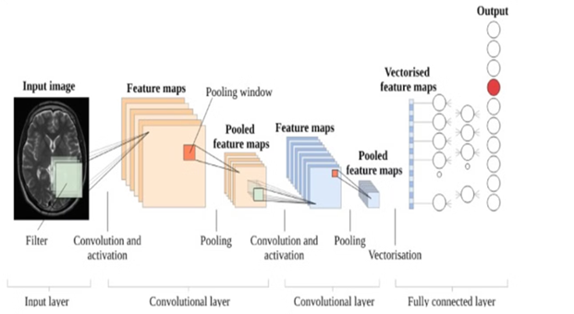

3.2 METHODOLOGY

3.2.1 Principle of Operation
- Data Acquisition – MRI scan images of the brain are collected as input data.
- Preprocessing – Images are resized, normalized, and augmented to improve accuracy.
- Feature Extraction – A Convolutional Neural Network (CNN) extracts spatial features such as tumor edges, texture, and patterns.
- Classification – The CNN model classifies the MRI scans as tumor or non-tumor, and if a tumor is present, it categorizes the type.
- Diagnosis & Prediction – The trained model provides probability scores and visual heatmaps to highlight tumor regions for analysis.
- Location & Mail Feature – If a tumor is detected, the system automatically fetches the user's location and emails the scan report and diagnosis details to the concerned medical professional or patient.
- Evaluation – The model's performance is assessed using metrics like accuracy, precision, recall, and F1-score.

3.2.2 System work flow
- User Authentication – Verifies if the user is authorized.
- Upload MRI Image – User uploads the brain scan.
- Otsu Thresholding – Segments the tumor from the background.
- Generate Train & Test Model – Splits data for training and testing.
- Generate Deep Learning CNN Model – Extracts features and classifies tumors.
- Predict Output – Determines if a tumor is present.
- End Process – Displays the result and exits.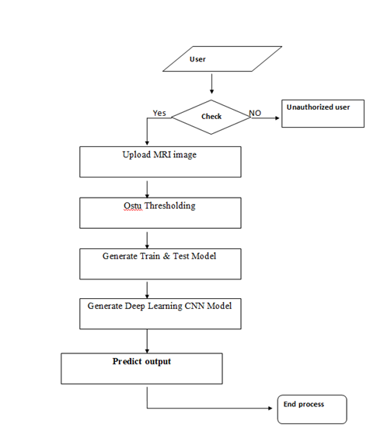

3.3 HARDWARE CONFIGURATION
Peripherals – Some software applications need to make extensive and/or special use of some peripherals, demanding the higher performance or functionality of such peripherals. Such peripherals include CD-ROM drives, keyboards, pointing devices, network devices, etc.
1) Operating System: Windows, Linux
2) Processor: i3 and above
3) Ram: 4 Giga Byte and above
4) Hard Disk: 250 Giga Byte in local drive
5)Cooling System: Proper cooling (liquid cooling or multiple fans) to prevent overheating during extended training sessions.

Chapter: 4 SYSTEM DESIGN

4.1 INTRODUCTION
The system design for brain tumor detection using deep learning involves multiple components working together to process MRI images, extract features, classify tumors, and provide diagnostic results. The system follows a structured workflow, integrating image processing techniques, machine learning models, and automated communication features. The system is designed with a client-server architecture, where users upload MRI images, and the backend processes them using a CNN-based deep learning model. The processed results are then displayed to the user, and if a tumor is detected, location-based alerts and email notifications are triggered.

Key Design Components:
- User Interface (UI):
  - A web or desktop-based interface where users can upload MRI images.
  - Provides access control to ensure authorized usage.
- Image Processing Module:
  - Otsu’s Thresholding for segmentation to enhance tumor visibility.
  - Preprocessing steps such as resizing, normalization, and noise reduction.
- Machine Learning Model:
  - Uses a Convolutional Neural Network (CNN) for feature extraction and classification.
  - The model is trained on labelled MRI datasets to distinguish between tumor and non-tumor cases.
- Database & Storage:
  - Stores user details, uploaded MRI images, and processed results.
  - Can be implemented using SQL or NoSQL databases (MySQL, MongoDB, etc.).
- Backend Processing & API Layer:
  - Manages communication between the UI, machine learning model, and database.
  - Developed using Python (Flask/Django)
- Notification System:
  - Sends email notifications containing the diagnosis report if a tumor is detected.
  - Fetches location data to provide hospital recommendations.

4.2 UML DIAGRAMS

UML stands for Unified Modeling Language. UML is a standardized general-purpose modeling language in the field of object-oriented software engineering. The standard is managed, and was created by, the Object Management Group.

The goal is for UML to become a common language for creating models of object oriented computer software. In its current form UML is comprised of two major components: a Meta-model and a notation. In the future, some form of method or process may also be added to; or associated with, UML.

The Unified Modeling Language is a standard language for specifying, Visualization, Constructing and documenting the artifacts of software system, as well as for business modeling and other non-software systems.

The UML represents a collection of best engineering practices that have proven successful in the modeling of large and complex systems.

The UML is a very important part of developing object-oriented software and the software development process. The UML uses mostly graphical notations to express the design of software projects.

GOALS:

The Primary goals in the design of the UML are as follows:

Provide users a ready-to-use, expressive visual modeling Language so that they can develop and exchange meaningful models.

Provide extendibility and specialization mechanisms to extend the core concepts.

Be independent of particular programming languages and development process.

Provide a formal basis for understanding the modeling language.

Encourage the growth of OO tools market.

Support higher level development concepts such as collaborations, frameworks, patterns and components.

Integrate best practices.

4.2.1 Use Case Diagram

A use case diagram in the Unified Modeling Language (UML) is a type of behavioral diagram defined by and created from a Use-case analysis. Its purpose is to present a graphical overview of the functionality provided by a system in terms of actors, their goals (represented as use cases), and any dependencies between those use cases. The main purpose of a use case diagram is to show what system functions are performed for which actor. Roles of the actors in the system can be depicted.
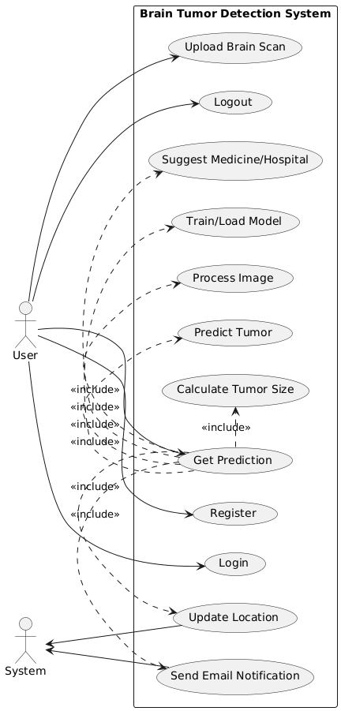
Fig 4.2.1: Use case Diagram

4.2.2 Class diagram

The class diagram is used to refine the use case diagram and define a detailed design of the system. The class diagram classifies the actors defined in the use case diagram into a set of interrelated classes. The relationship or association between the classes can be either an "is-a" or "has-a" relationship. Each class in the class diagram may be capable of providing certain functionalities. These functionalities provided by the class are termed "methods" of the class. Apart from this, each class may have certain "attributes" that uniquely identify the class.

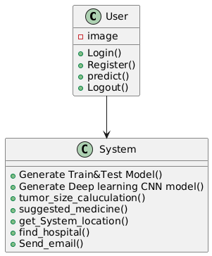
Fig 4.2.2: Class Diagram

4.2.3 Sequence diagram

A sequence diagram represents the interaction between different objects in the system. The important aspect of a sequence diagram is that it is time-ordered. This means that the exact sequence of the interactions between the objects is represented step by step. Different objects in the sequence diagram interact with each other by passing "messages".

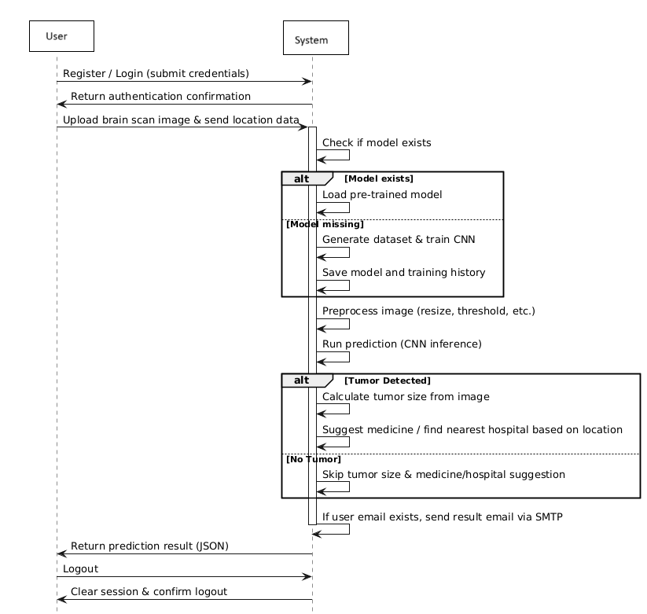
Fig 4.2.3: Sequence Diagram

4.2.4 Activity diagram

The process flows in the system are captured in the activity diagram. Similar to a state diagram, an activity diagram also consists of activities, actions, transitions, initial and final states, and guard conditions.

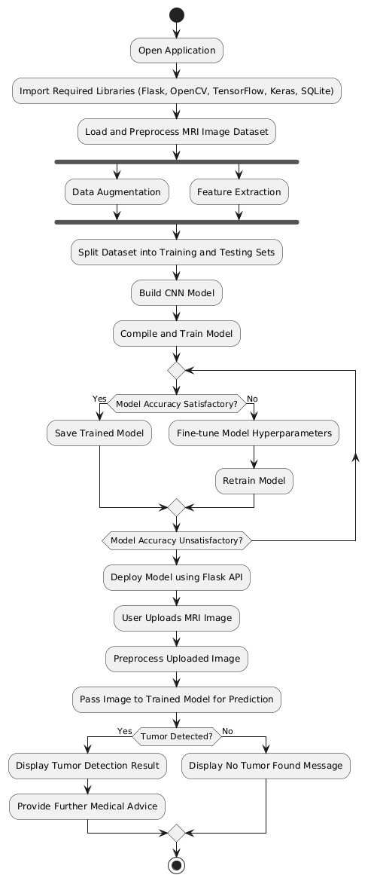

Fig 4.2.4: Activity Diagram

4.2.5 Collaboration diagram

A collaboration diagram groups together the interactions between different objects. The interactions are listed as numbered interactions that help to trace the sequence of the interactions. The collaboration diagram helps to identify all the possible interactions that each object has with other objects.
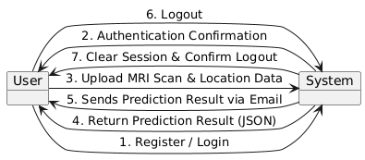

Fig 4.2.5: Collaboration Diagram

4.2.6 Component diagram
The component diagram represents the high-level parts that make up the system. This diagram depicts, at a high level, what components form part of the system and how they interrelated.
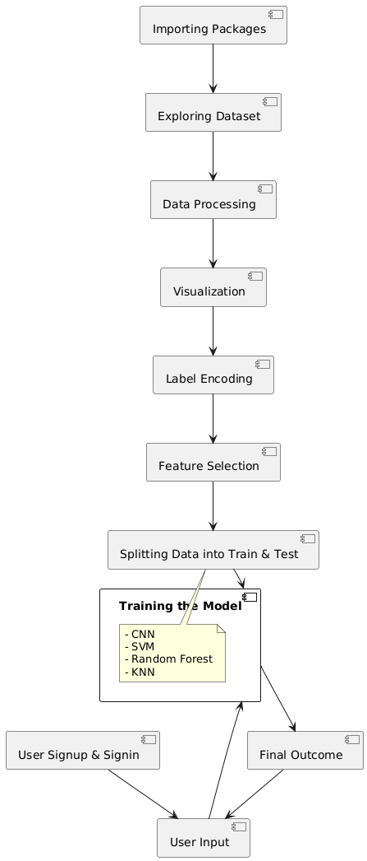

Fig 4.2.6: Component Diagram

4.2.7 Deployment diagram

The deployment diagram captures the configuration of the runtime elements of the application. This diagram is by far most useful when a system is built and ready to be deployed.

Fig 4.2.7: Deployment Diagram

Chapter: 5 SYSTEM IMPLEMENTATION

5.1 IMPLEMENTATION
MODULES:

Data exploration: This module is responsible for loading MRI scan data into the system, ensuring it is correctly formatted for further analysis.

Image processing: This module processes MRI images by transforming them into a digital format and applying various preprocessing techniques (such as noise reduction, contrast enhancement, and segmentation) to extract meaningful features.

Model generation: This module builds and trains a Convolutional Neural Network (CNN) for brain tumor detection. The model is trained using preprocessed MRI scan data, optimized with techniques such as data augmentation and hyperparameter tuning to improve accuracy.

User signup & login: Using this module will get registration and login. This module handles user registration and authentication, allowing users to securely access the system.

User input: This module enables users to upload MRI scan images for tumor detection and diagnosis.

Prediction: The system processes the uploaded image and runs it through the trained model. The final prediction result is displayed, indicating whether a tumor is present. If a tumor is detected, additional details such as tumor size and recommendations for further medical consultation may be provided.
Dataset
- MRI Images: https://www.kaggle.com/datasets/navoneel/brain-mri-images-for-brain-tumor-detection

Extension
In the base paper, the author proposed using different techniques for analyzing medical image datasets with Machine Learning models. As an enhancement, we implemented a Convolutional Neural Network (CNN) model to accurately detect brain tumors from MRI scans.
To further improve performance, we applied image preprocessing techniques such as data augmentation, normalization, and noise reduction before passing the images to the CNN model. The trained model demonstrated high accuracy in detecting brain tumors.
As an additional extension, we can develop a front-end interface using the Flask framework, allowing users to upload MRI images, receive real-time predictions, and view analysis results. Furthermore, user authentication can be implemented to ensure secure access to the system.
Algorithms:
CNN
A CNN is a kind of network architecture for deep learning algorithms and is specifically used for image recognition and tasks that involve the processing of pixel data. There are other types of neural networks in deep learning, but for identifying and recognizing objects, CNNs are the network architecture of choice.
Artificial neural network
Artificial neural networks are one of the main tools used in machine learning. As the “neural” part of their name suggests, they are brain-inspired systems which are intended to replicate the way that we humans learn. Neural networks consist of input and output layers, as well as (in most cases) a hidden layer consisting of units that transform the input into something that the output layer can use. They are excellent tools for finding patterns which are far too complex or numerous for a human programmer to extract and teach the machine to recognize.

5.2 SOURCE CODE

app.py

import matplotlib.pyplot as plt

from werkzeug.security import generate_password_hash, check_password_hash

from flask import Flask, render_template, request, jsonify, session, redirect, url_for

import numpy as np

import os

import cv2

from sklearn.model_selection import train_test_split

from sklearn.metrics import accuracy_score

import imutils

from keras.utils.np_utils import to_categorical

from keras.layers import MaxPooling2D

from keras.layers import Dense, Dropout, Activation, Flatten

from keras.layers import Convolution2D

from keras.models import Sequential

from keras.models import model_from_json

import pickle

from sklearn import metrics

import ftplib

import math

import sqlite3

import requests

from geopy.geocoders import Nominatim

from geopy.distance import geodesic

import smtplib

from dotenv import load_dotenv

from email.mime.text import MIMEText

from email.mime.multipart import MIMEMultipart

app = Flask(__name__)

app.secret_key = 'brain_tumor'

global filename

global accuracy

X = []

Y = []

global classifier

disease = ['No Tumor Detected','Tumor Detected']

filename = "./dataset"

load_dotenv()

# Gmail credentials from .env file

GMAIL_USERNAME = os.getenv("GMAIL_USERNAME")

GMAIL_PASSWORD = os.getenv("GMAIL_PASSWORD")

@app.before_first_request

def create_users_table():

try:

conn = sqlite3.connect('users.db')

cursor = conn.cursor()

cursor.execute('''

CREATE TABLE IF NOT EXISTS users (

id INTEGER PRIMARY KEY AUTOINCREMENT,

name TEXT NOT NULL,

email TEXT UNIQUE NOT NULL,

password TEXT NOT NULL

)

''')

conn.commit()

print("Table created successfully.")

except sqlite3.Error as e:

print(f"Error creating table: {e}")

finally:

conn.close()

@app.route('/')

def index():

if 'user_email' not in session:

return redirect('/login')

return render_template('index.html', user_name=session.get('user_name'))

@app.route('/register', methods=['GET', 'POST'])

def register():

if request.method == 'GET':

return render_template('register.html')

name = request.form.get('name')

email = request.form.get('email')

password = request.form.get('password')

if not name or not email or not password:

return "Name, Email, and Password are required!", 400

hashed_password = generate_password_hash(password

try:

conn = sqlite3.connect('users.db')

cursor = conn.cursor()

cursor.execute("SELECT * FROM users WHERE email = ?", (email,))

user = cursor.fetchone()

if user:

return "This email is already registered. Please login instead."

cursor.execute("INSERT INTO users (name, email, password) VALUES (?, ?, ?)", (name, email, hashed_password))

conn.commit()

return redirect('/login')

except sqlite3.Error as e:

return f"An error occurred: {e}"

finally:

conn.close()

@app.route('/login', methods=['GET', 'POST'])

def login():

if request.method == 'GET':

if 'user_email' in session:

return redirect('/')

return render_template('login.html')

email = request.form.get('email')

password = request.form.get('password')

if not email or not password:

return "Email and Password are required!", 400

try:

conn = sqlite3.connect('users.db')

cursor = conn.cursor()

cursor.execute("SELECT * FROM users WHERE email = ?", (email,))

user = cursor.fetchone()

if user and check_password_hash(user[3], password):

session['user_name'] = user[1]

session['user_email'] = user[2]

return redirect('/')

else:

return "Invalid email or password. Please try again."

except sqlite3.Error as e:

return f"An error occurred: {e}"

finally:

conn.close()

@app.route('/predict', methods=['POST'])

def predict():

global disease

global classifier

if 'classifier' not in globals():

classifier = None

if classifier is None:

generateModel()

CNN()

# Get the image file

file = request.files['image']

# Get user email from session

user_email = session.get('user_email', None)

# Get location data from the request

latitude = float(request.form.get('latitude', 0.0))

longitude = float(request.form.get('longitude', 0.0))

location = {"latitude": latitude, "longitude": longitude}

# Process the image

image = cv2.imdecode(np.frombuffer(file.read(), np.uint8), cv2.IMREAD_GRAYSCALE)

img_resized = cv2.resize(image, (128, 128)).reshape(1, 128, 128, 1)

prediction = classifier.predict(np.array(img_resized))

cls = np.argmax(prediction)

if cls == 1: # Tumor Detected

_, binary_img = cv2.threshold(image, 0, 255, cv2.THRESH_BINARY + cv2.THRESH_OTSU)

scale_factor = 0.01 # Adjust based on actual dataset scale

tumor_size_cm = calculate_tumor_size_in_cm(binary_img, scale_factor)

t_length = math.sqrt(math.sqrt(tumor_size_cm))

s_m = suggest_medicine(t_length)

if s_m == "Suggested Medicine: Go to hospital":

nearest_hospital = find_nearest_hospital_with_osm(location)

else:

nearest_hospital = s_m

result = {

"prediction": disease[cls],

"tumor_size": f"{t_length:.2f} cm",

"medicine": nearest_hospital

}

else:

result = {

"prediction": disease[cls],

"tumor_size": " --",

"medicine": " --"

}

if user_email:

send_email(user_email, result)

return jsonify(result)

def generateModel():

global X

global Y

X.clear()

Y.clear()

if os.path.exists('Model/myimg_data.txt.npy'):

X = np.load('Model/myimg_data.txt.npy')

Y = np.load('Model/myimg_label.txt.npy')

else:

for root, dirs, directory in os.walk(filename+"/no"):

for i in range(len(directory)):

name = directory[i]

img = cv2.imread(filename+"/no/"+name,0)

ret2,th2 = cv2.threshold(img,0,255,cv.THRESH_BINARY+cv.THRESH_OTSU)

img = cv2.resize(img, (128,128))

im2arr = np.array(img)

im2arr = im2arr.reshape(128,128,1)

X.append(im2arr)

Y.append(0)

for root, dirs, directory in os.walk(filename+"/yes"):

for i in range(len(directory)):

name = directory[i]

img = cv2.imread(filename+"/yes/"+name,0)

ret2,th2 = cv.threshold(img,0,255,cv.THRESH_BINARY+cv.THRESH_OTSU)

img = cv2.resize(img, (128,128))

im2arr = np.array(img)

im2arr = im2arr.reshape(128,128,1)

X.append(im2arr)

Y.append(1)

X = np.asarray(X)

Y = np.asarray(Y)

np.save("Model/myimg_data.txt",X)

np.save("Model/myimg_label.txt",Y)

def CNN():

global accuracy

global classifier

YY = to_categorical(Y)

indices = np.arange(X.shape[0])

np.random.shuffle(indices)

x_train = X[indices]

y_train = YY[indices]

if os.path.exists('Model/model.json'):

with open('Model/model.json', "r") as json_file:

loaded_model_json = json_file.read()

classifier = model_from_json(loaded_model_json)

classifier.load_weights("Model/model_weights.h5")

f = open('Model/history.pckl', 'rb')

data = pickle.load(f)

f.close()

acc = data['accuracy']

accuracy = acc[9] * 100

print("Accuracy:", accuracy)

else:

X_trains, X_tests, y_trains, y_tests = train_test_split(x_train, y_train, test_size = 0.2, random_state = 0)

classifier = Sequential()

classifier.add(Convolution2D(32, 3, 3, input_shape = (128, 128, 1), activation = 'relu'))

classifier.add(MaxPooling2D(pool_size = (2, 2)))

classifier.add(Convolution2D(32, 3, 3, activation = 'relu'))

classifier.add(MaxPooling2D(pool_size = (2, 2)))

classifier.add(Flatten())

classifier.add(Dense(output_dim = 128, activation = 'relu'))

classifier.add(Dense(output_dim = 2, activation = 'softmax'))

classifier.compile(optimizer = 'adam', loss = 'categorical_crossentropy', metrics = ['accuracy'])

hist = classifier.fit(x_train, y_train, batch_size=16, epochs=10,validation_split=0.2, shuffle=True, verbose=2)

classifier.save_weights('Model/model_weights.h5')

model_json = classifier.to_json()

with open("Model/model.json", "w") as json_file:

json_file.write(model_json)

f = open('Model/history.pckl', 'wb')

pickle.dump(hist.history, f)

f.close()

f = open('Model/history.pckl', 'rb')

data = pickle.load(f)

f.close()

acc = data['accuracy']

accuracy = acc[9] * 100

print("Accuracy:", accuracy)

@app.route('/update-location', methods=['POST'])

def update_location():

data = request.get_json()

latitude = data.get('latitude')

longitude = data.get('longitude')

return {"latitude": latitude, "longitude": longitude}

def calculate_tumor_size_in_cm(binary_img, scale_factor):

"""

Calculate tumor size in cm² based on binary image and scale factor.

"""

# Find contours of the tumor region

contours, _ = cv2.findContours(binary_img, cv2.RETR_EXTERNAL, cv2.CHAIN_APPROX_SIMPLE)

total_area_pixels = 0

for contour in contours:

total_area_pixels += cv2.contourArea(contour)

# Convert pixel area to cm²

tumor_size_cm = total_area_pixels * scale_factor

return tumor_size_cm

def suggest_medicine(tumor_size):

"""

Suggest medicines based on tumor size.

"""

if tumor_size <= 3:

return "Suggested Medicine: Aspirin (for pain relief)"

elif 3 < tumor_size <= 4.5:

return "Suggested Medicine: Dexamethasone (to reduce swelling)"

elif 4.5 < tumor_size <= 5.5:

return "Suggested Medicine: Temozolomide (chemotherapy drug)"

else:

return "Suggested Medicine: Go to hospital"

def find_nearest_hospital_with_osm(location):

"""

Find the nearest hospital using OpenStreetMap's Overpass API with improved accuracy.

"""

try:

overpass_url = "http://overpass-api.de/api/interpreter"

query = f"""

[out:json];

node

["amenity"="hospital"]

(around:3000,{location['latitude']},{location['longitude']});

out body;

"""

response = requests.get(overpass_url, params={"data": query})

if response.status_code == 200:

data = response.json()

if "elements" in data and len(data["elements"]) > 0:

hospitals = []

for hospital in data["elements"]:

lat, lon = hospital["lat"], hospital["lon"]

distance = geodesic((location['latitude'], location['longitude']), (lat, lon)).meters

hospitals.append((distance, hospital))

# Sort hospitals by distance (smallest first)

hospitals.sort(key=lambda x: x[0])

nearest_hospital = hospitals[0][1]

name = nearest_hospital.get("tags", {}).get("name", "Brain Hospital")

lat, lon = nearest_hospital["lat"], nearest_hospital["lon"]

return f"{name} (Latitude: {lat}, Longitude: {lon})"

else:

return "No nearby hospitals found."

else:

return "Error fetching hospital data from OSM."

except Exception as e:

print(f"Error: {e}")

return "Unable to fetch hospital data."

def send_email(to_gmail, result):

subject = "Brain Tumor Prediction Result"

msg_content = f"""Dear User,

Here is your brain tumor prediction result:

- Prediction: {result['prediction']}

- Tumor Size: {result['tumor_size']}

- Suggested Medicine / Nearest Hospital: {result['medicine']}

Please consult a doctor if necessary.

Best regards,

Brain Tumor Detection Project Team

- Sk. Ajith

- G. HariChandan

- M. Bhargav

- L. Jaya Sankar

"""

try:

# Establish connection inside the function

connection = smtplib.SMTP('smtp.gmail.com', 587)

connection.starttls()

connection.login(GMAIL_USERNAME, GMAIL_PASSWORD)

# Create email message

msg = MIMEMultipart()

msg['From'] = GMAIL_USERNAME

msg['To'] = to_gmail

msg['Subject'] = subject

msg.attach(MIMEText(msg_content, 'plain'))

# Send email

connection.sendmail(GMAIL_USERNAME, to_gmail, msg.as_string())

# Close the connection

connection.quit()

print("Email sent successfully!")

except Exception as e:

print("Error Sending Email:", e)

@app.route('/logout')

def logout():

session.clear()

return redirect('/login')

if __name__ == '__main__':

app.run(debug=True)

Index.html
<!DOCTYPE html>
<html lang="en">
<head>
<meta charset="UTF-8">
<meta name="viewport" content="width=device-width, initial-scale=1.0">
<title>Brain Tumor Prediction</title>
<link rel="stylesheet" href="{{ url_for('static', filename='styles.css') }}">
</head>
<body>
<div class="container">
<h1>Detecting and Diagnosing Brain Tumors using ML</h1>
<form id="uploadForm" action="/predict" method="post" enctype="multipart/form-data">
<input type="file" name="image" id="imageInput" accept="image/*" required>
<button type="submit">Predict Tumor</button>
</form>
<img id="preview">
<div id="status"></div>
<div id="result"></div>
<div id="logot"><a href="/logout">Logout</a></div>
</div>

<script>
document.getElementById('imageInput').addEventListener('change', function(event) {
const file = event.target.files[0];
if (file) {
const reader = new FileReader();
reader.onload = function(e) {
const preview = document.getElementById('preview');
preview.src = e.target.result;
preview.style.display = 'block';
};
reader.readAsDataURL(file);
}
});

document.getElementById('uploadForm').onsubmit = async function(event) {
event.preventDefault(); // Prevent default form submission

const formData = new FormData(this);

// Get location and append it to the formData
if (navigator.geolocation) {
navigator.geolocation.getCurrentPosition(
async (position) => {
const lat = position.coords.latitude;
const lon = position.coords.longitude;

// Append latitude and longitude to the formData
formData.append('latitude', lat);
formData.append('longitude', lon);

showMessage("Uploading... Please wait.");

try {
const response = await fetch('/predict', {
method: 'POST',
body: formData
});

if (!response.ok) {
throw new Error('Failed to process the image');
}

const data = await response.json();
document.getElementById('result').innerHTML = `
<p><b>Prediction:</b> ${data.prediction}</p>
<p><b>Medicine:</b> ${data.medicine}</p>
<p><b>Tumor Size:</b> ${data.tumor_size}</p>
`;
showMessage("Prediction successful!");
} catch (error) {
showMessage("Error: " + error.message);
}
},
(error) => {
console.error('Error fetching location:', error);
showMessage("Unable to get location. Please enable location services and try again.");
}
);
} else {
alert("Geolocation is not supported by this browser.");
showMessage("Geolocation is not supported by this browser.");
}
};

function showMessage(message) {
document.getElementById('status').innerText = message;
}

</script>

</body>
</html>

Login.html
<!DOCTYPE html>
<html>
<head>
<title>Login</title>
<style>
body{
font-family:Verdana;
width:100%;
height:800px;
background:linear-gradient(#1D2B64,#F8CDDA);
background-repeat:no-repeat;
background-size:cover;
color:white;
}
.do{
width:500px;
height:200px;
border:1px solid white;
box-shadow:rgba(0,0,0,1);
border-radius:15px;
margin:50px auto;
padding: 50px;
text-align:center;
font-size:1.3rem;
}
h1{
margin-top:75px;
text-align:center;
font-family:Arial;
font-size:3rem;
}
p{
margin-top:30px;
font-family:verdana;
}
a:hover{
color:white;
}
a{
text-decoration:none;
color:black;
}
button{
padding:12px 20px;
border-radius:10px;
}
</style>
</head>
<body>
<h1>Login</h1>
<div class="do">
<form method="POST" action="/login">
<label for="email">Email:</label>
<input type="email" id="email" name="email" required>
<br><br>
<label for="password">Password:</label>
<input type="password" id="password" name="password" required>
<br><br>
<button type="submit">Login</button>
</form>
<p>Don't have an account? <a href="/register">Register here.</a></p>
</div>
</body>
</html>

Register.html
<!DOCTYPE html>
<html>
<head>
<title>Register</title>
<style>
body{
font-family:Verdana;
width:100%;
height:800px;
background:linear-gradient(#fff1eb,#ace0f9);
background-repeat:no-repeat;
background-size:cover;
color:black;
}
h1{
margin-top:75px;
text-align:center;
font-family:Arial;
font-size:3rem;
}
.reg{
width:500px;
height:220px;
border:1px solid black;
box-shadow:rgba(0,0,0,1);
border-radius:15px;
margin:50px auto;
padding: 50px;
text-align:center;
font-size:1.3rem;
}
p{
margin-top:20px;
font-family:verdana;
}
button{
padding:12px 20px;
border-radius:10px;
}
.bu{
margin:15px;
}
a{
color:grey;
text-decoration:none;
}
a:hover{
color:red;
}
</style>
</head>
<body>
<h1>Register</h1>
<div class="reg">
<form method="POST" action="/register">
<div><label for="name">Name:</label>
<input type="text" id="name" name="name" required></div>
<br>
<div><label for="email">Email:</label>
<input type="email" id="email" name="email" required></div>
<br>
<div><label for="password">Password:</label>
<input type="password" id="password" name="password" required></div>
<div class="bu"><button type="submit">Register</button></div>
</form>
<p>Already have an account? <a href="/login">Login here.</a></p>
</div>
</body>
</html>

styles.css
body {
font-family: Arial, sans-serif;
background-color: #f4f4f4;
text-align: center;
}
.container {
margin: 50px auto;
padding: 20px;
background: white;
box-shadow: 0px 0px 10px rgba(0, 0, 0, 0.3);
width: 50%;
border-radius: 15px;
}
input, button {
padding: 10px;
margin: 10px 0;
}
button {
background-color: rgb(12, 18, 71);
color: white;
border: none;
cursor: pointer;
padding:15px;
border-radius:8px;
}
button:hover {
background-color: rgb(125, 142, 209);
}
#preview {
width: 300px;
height: 300px;
object-fit: cover;
display: none;
border-radius:15px;
margin: 20px auto;
}
body{
background: linear-gradient(180deg, rgb(12, 18, 71), rgb(40, 51, 125) 28%, rgb(80, 93, 173) 46%, rgb(125, 142, 209) 60%, rgb(174, 188, 230) 75%, rgb(239, 236, 255) 90%, rgb(255, 255, 255));
background-repeat:no-repeat;
width:100%;
height:700px;
}
a{
text-decoration:none;
color:red;
}
#logot{
padding:20px;
}

5.3 OUTPUT
SCREENSSHOTS
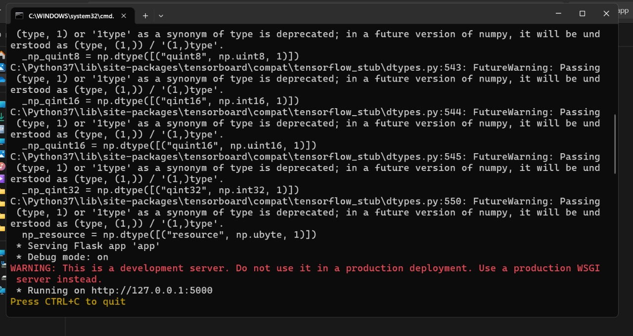

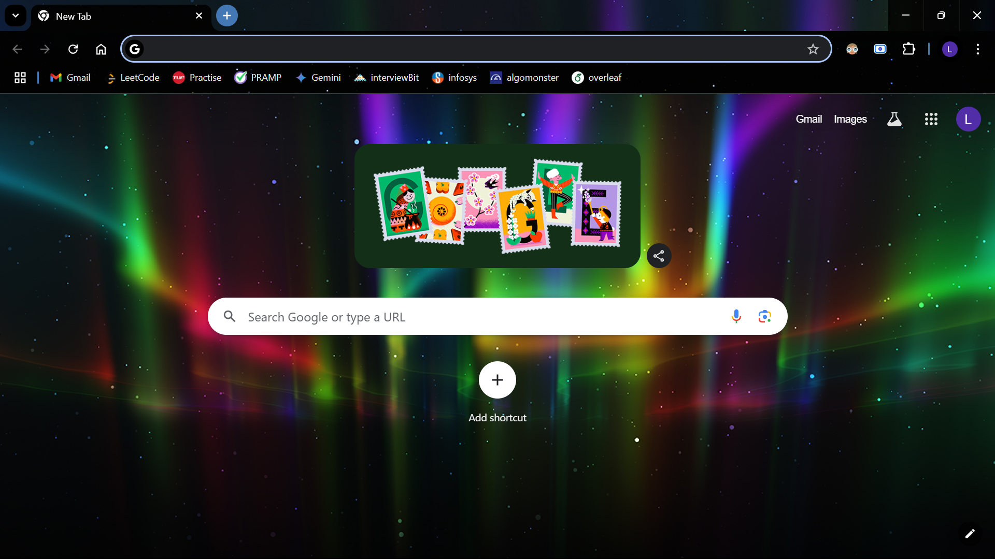
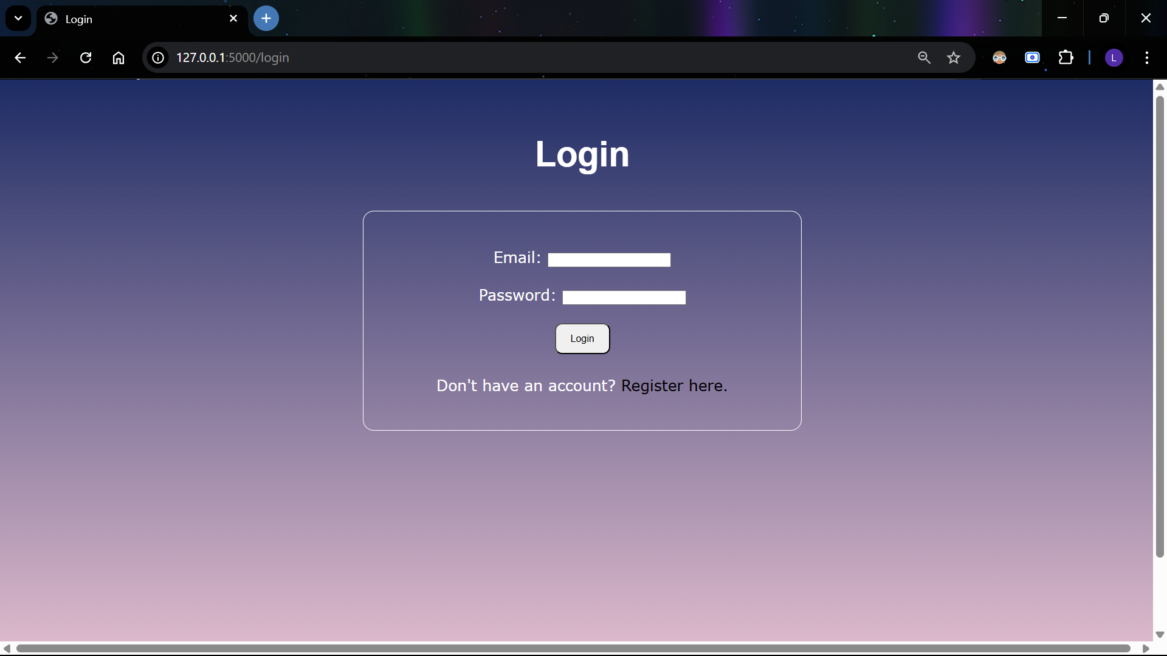

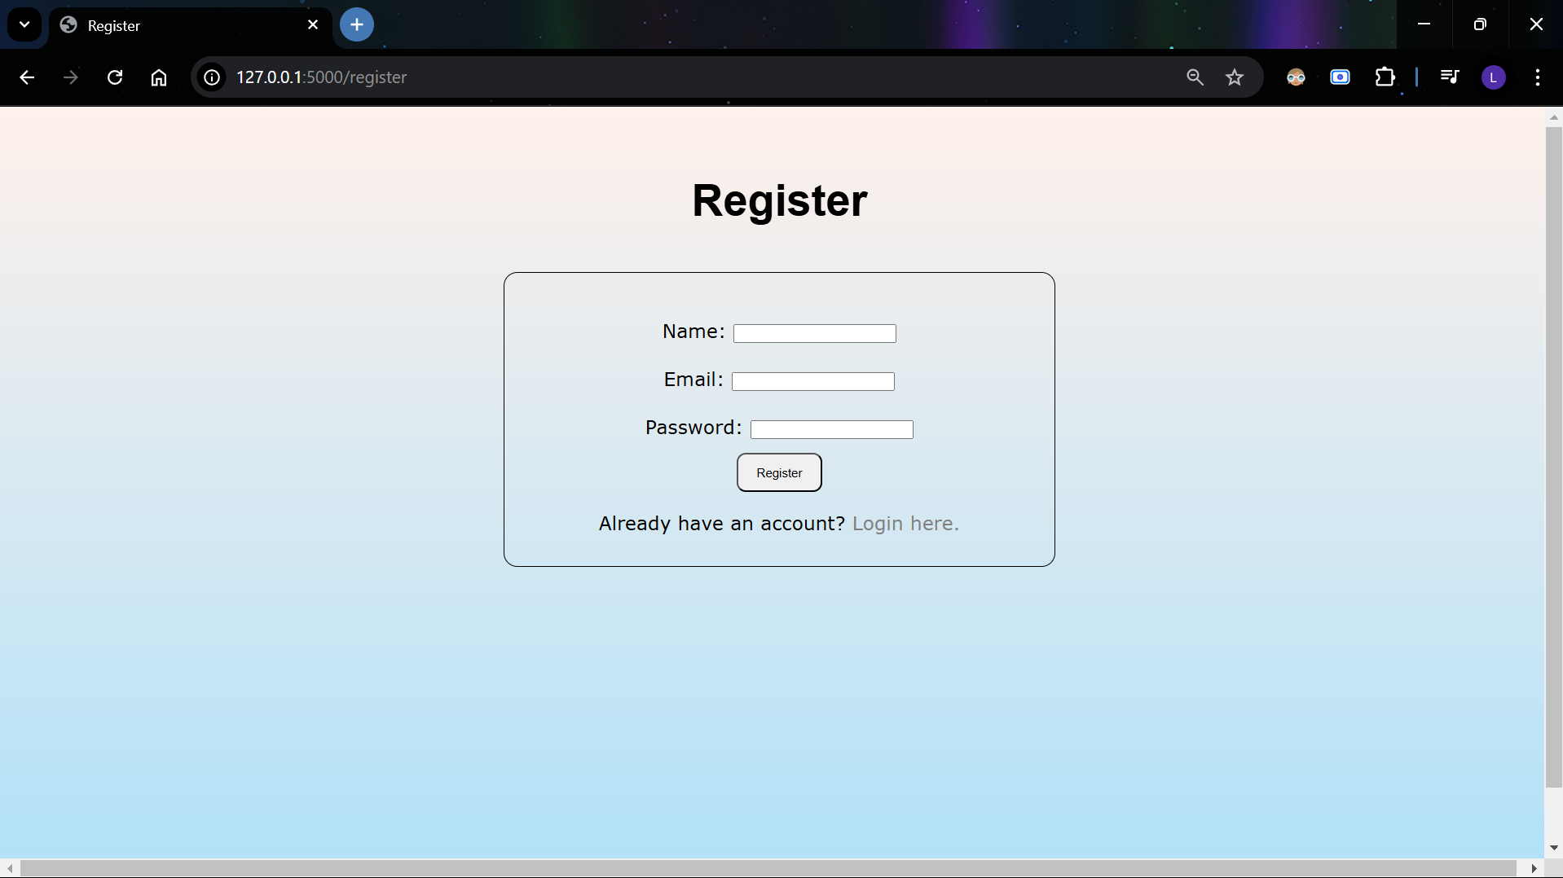
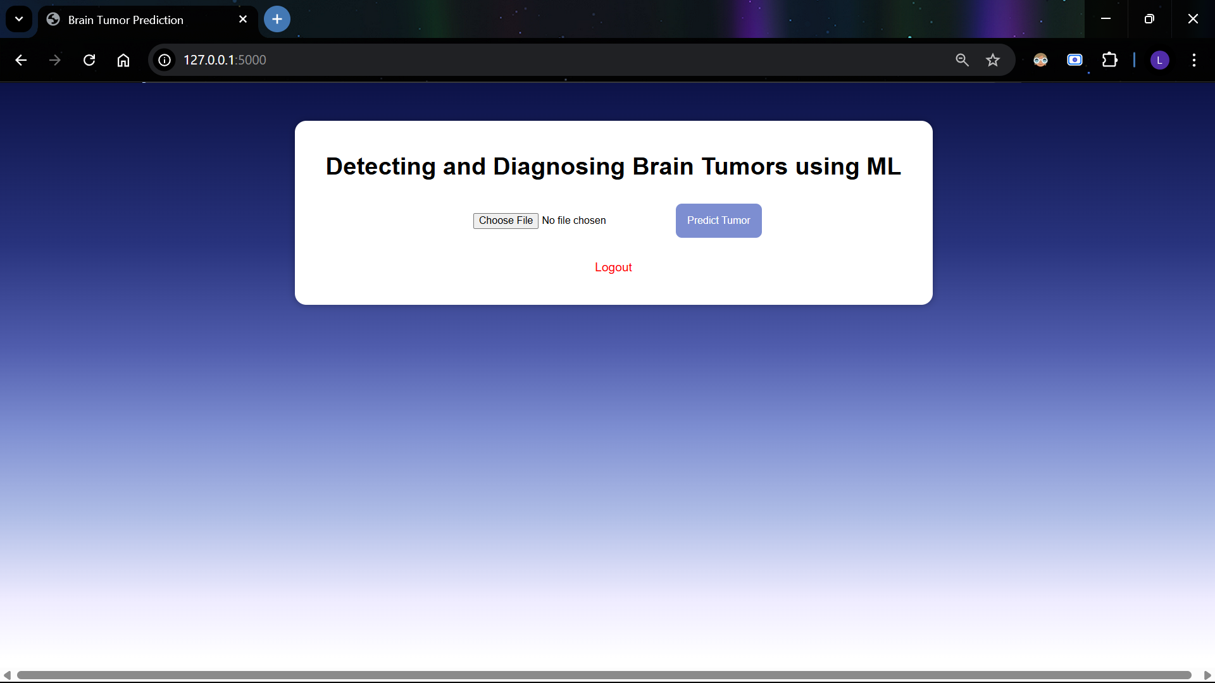

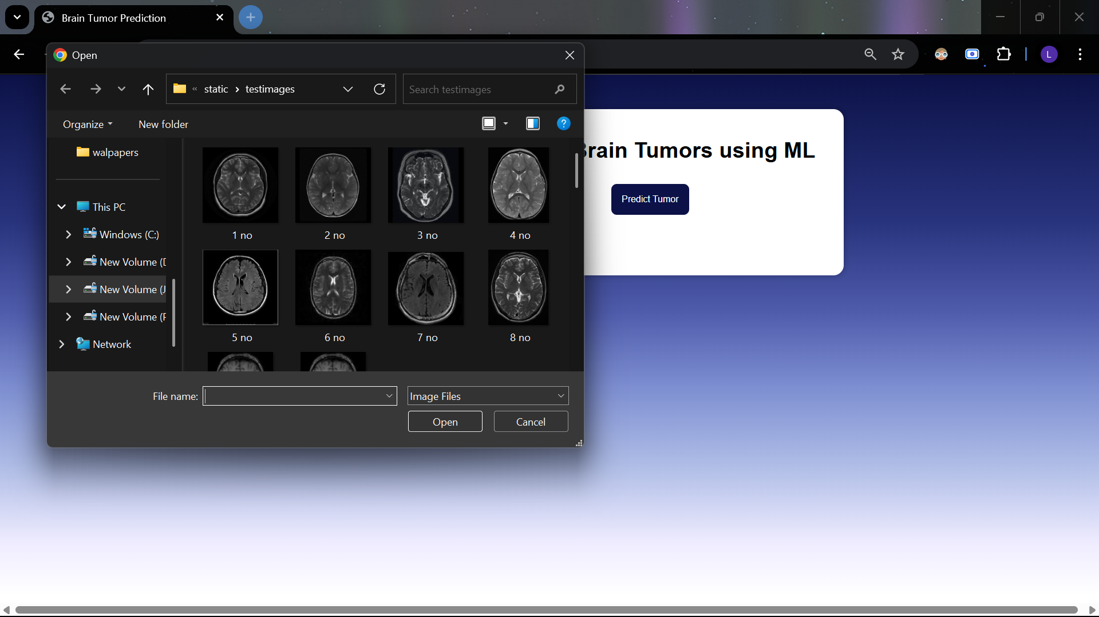
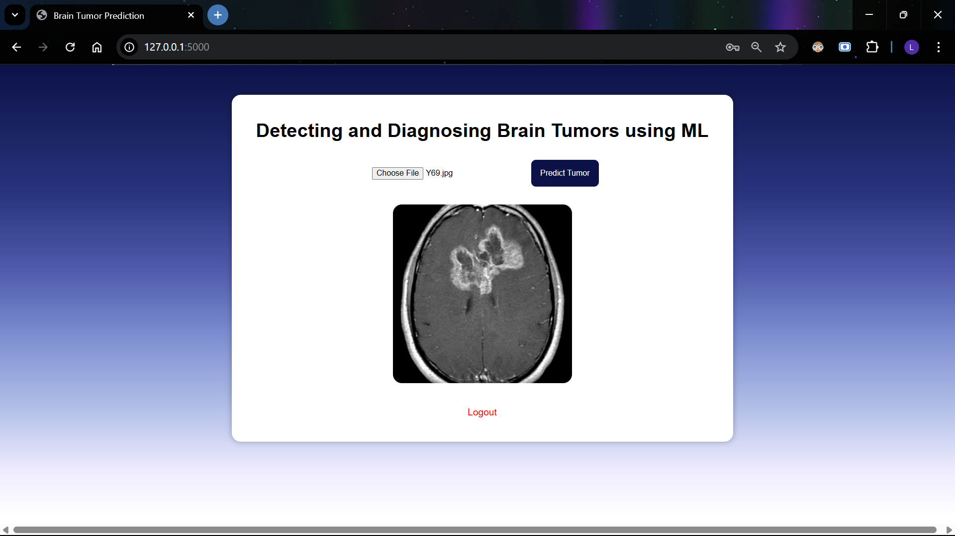

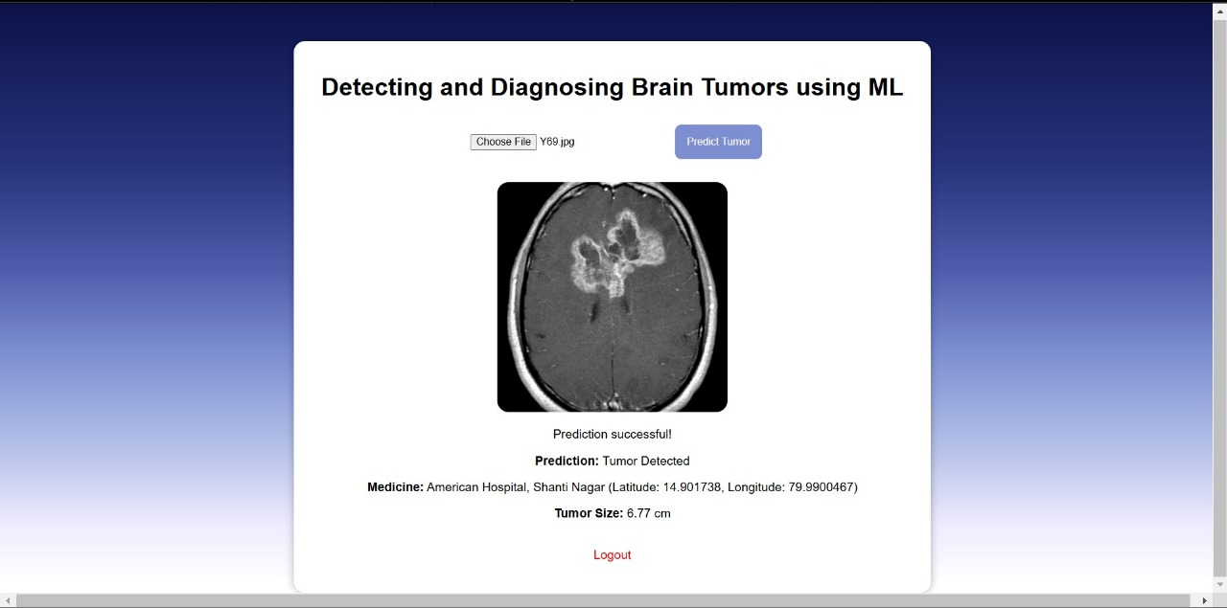

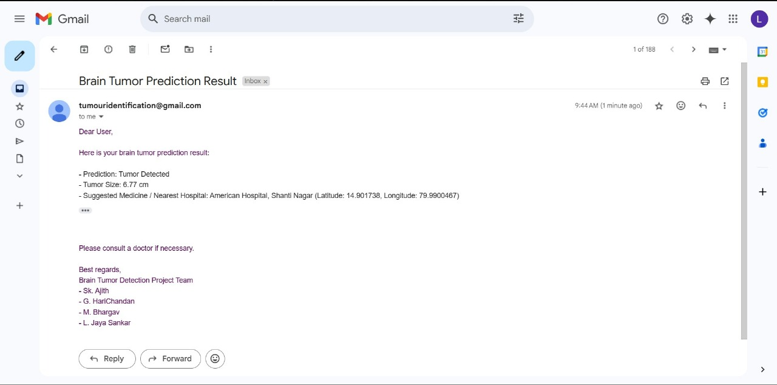

Chapter: 6 SYSTEM TESTING

System testing, also referred to as system-level tests or system-integration testing, is the process in which a quality assurance (QA) team evaluates how the various components of an application interact together in the full, integrated system or application. System testing verifies that an application performs tasks as designed. This step, a kind of black box testing, focuses on the functionality of an application. System testing, for example, might check that every kind of user input produces the intended output across the application.

Phases of system testing:

A video tutorial about this test level. System testing examines every component of an application to make sure that they work as a complete and unified whole. A QA team typically conducts system testing after it checks individual modules with functional or user-story testing and then each component through integration testing.

If a software build achieves the desired results in system testing, it gets a final check via acceptance testing before it goes to production, where users consume the software. An app-dev team logs all defects, and establishes what kinds and amount of defects are tolerable.
Software Testing Strategies:

Optimization of the approach to testing in software engineering is the best way to make it effective. A software testing strategy defines what, when, and how to do whatever is necessary to make an end-product of high quality. Usually, the following software testing strategies and their combinations are used to achieve this major objective:

6.1 TYPES OF TESTING

The early-stage testing strategy is static testing: it is performed without actually running the developing product. Basically, such desk-checking is required to detect bugs and issues that are present in the code itself. Such a check-up is important at the pre-deployment stage as it helps avoid problems caused by errors in the code and software structure deficits.
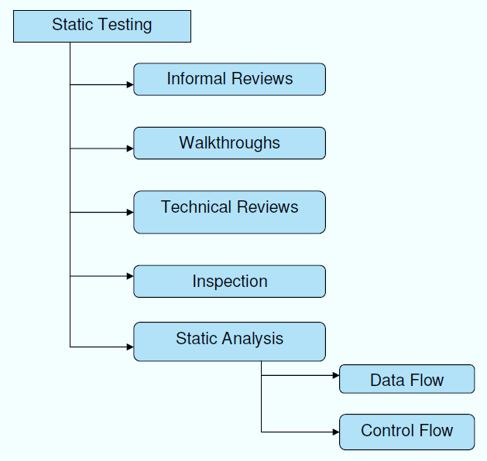

Structural Testing:

It is not possible to effectively test software without running it. Structural testing, also known as white-box testing, is required to detect and fix bugs and errors emerging during the pre-production stage of the software development process. At this stage, unit testing based on the software structure is performed using regression testing. In most cases, it is an automated process working within the test automation framework to speed up the development process at this stage. Developers and QA engineers have full access to the software’s structure and data flows (data flows testing), so they could track any changes (mutation testing) in the system’s behavior by comparing the tests’ outcomes with the results of previous iterations (control flow testing).
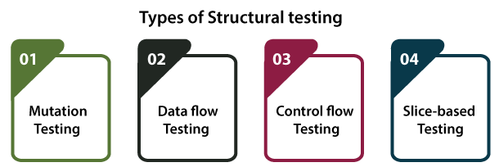
Behavioral Testing:
The final stage of testing focuses on the software’s reactions to various activities rather than on the mechanisms behind these reactions. In other words, behavioral testing, also known as black-box testing, presupposes running numerous tests, mostly manual, to see the product from the user’s point of view. QA engineers usually have some specific information about a business or other purposes of the software (‘the black box’) to run usability tests, for example, and react to bugs as regular users of the product will do. Behavioral testing also may include automation (regression tests) to eliminate human error if repetitive activities are required. For example, you may need to fill 100 registration forms on the website to see how the product copes with such an activity, so the automation of this test is preferable.
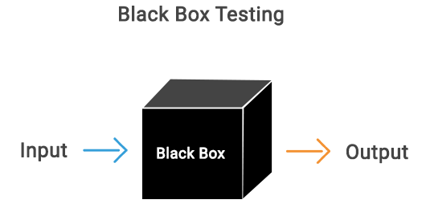

6.2 TEST CASES AND RESULTS

S.NO | INPUT | If available | If not available
1 | User signup | User get registered into the application | There is no process
2 | User sign in | User get login into the application | There is no process
3 | Enter input for prediction | Prediction result displayed | There is no process

Chapter: 7 CONCLUSION & FUTURE SCOPE

7.1 CONCLUSION
This project successfully demonstrates the application of deep learning in medical imaging by developing an efficient Brain Tumor Detection system. Utilizing TensorFlow / Keras for model training, OpenCV for image preprocessing, and Flask for deploying a user-friendly web interface, our system provides an accessible and effective tool for early tumor detection. SQLite was integrated for secure and efficient data management, ensuring a streamlined workflow for users.
The results indicate that deep learning models can significantly aid in the early diagnosis of brain tumors, potentially improving patient outcomes by facilitating timely medical intervention. While the current implementation offers promising accuracy and performance, future improvements could include expanding the dataset, incorporating more advanced neural network architectures, and integrating explainable AI techniques for better model interpretability.
This work underscores the transformative role of AI in healthcare, demonstrating how technology can complement medical expertise to enhance diagnostic capabilities.

7.2 FUTURE SCOPE
- Enhanced Model Accuracy
    - Improve CNN architecture with advanced deep learning techniques like Transformers, Vision Transformers (ViTs), or Hybrid CNN-RNN models for better detection and classification.
- Multi-Class Tumor Classification
    - Extend the model to classify different types of brain tumors (e.g., Glioma, Meningioma, Pituitary tumors) with higher precision.
- Integration with Medical Imaging Systems
    - Connect with PACS (Picture Archiving and Communication System) used in hospitals for real-time MRI analysis.
- Real-Time Diagnosis Using Edge AI
    - Deploy the model on edge devices (like NVIDIA Jetson Nano or Raspberry Pi) to enable instant tumor detection without requiring high-end servers.
- 3D Image Processing
    - Extend the system to analyse 3D MRI scans instead of 2D images, improving accuracy by capturing depth information.
- Explainable AI (XAI) for Medical Interpretability
    - Implement Grad-CAM or SHAP techniques to visualize which regions of MRI scans influenced the diagnosis, making the model interpretable for doctors.
- Cloud-Based AI Platform
    - Deploy the system on cloud services (AWS, GCP, or Azure) to allow remote access for medical professionals globally.
- Mobile Application for Accessibility
    - Develop a mobile app to let users upload MRI scans and receive instant diagnoses, improving accessibility in remote areas.
- Integration with Wearable Health Devices
    - Connect the system with IoT-based health monitoring devices for early symptom detection and AI-driven health tracking.
- Automated Report Generation with Recommendations
    - Use NLP models (like GPT or BERT) to generate detailed medical reports with suggested treatments based on AI analysis.

Chapter: 8 REFERENCES

- K. Nuresa Qodri, I. Soesanti and Ha. Adi Nugroho, "Image Analysis for MRIBASED Brain Tumor Classification Using Deep Learning", IJITEE, March 2021.
- A. Abougarair and Abdulhamid Oun, "Implementation of a Brain-Computer Interface for Robotic Arm Control", 2021 IEEE 1st International Maghreb Meeting of the Conference on Sciences and Techniques of Automatic Control and Computer Engineering (MI-STA2021), 25-27 may, 2021.
- How to Implement Classification in Machine Learning, [online] Available: https://www.edureka.co/blog/classification-in-machine-leaming/.
- M. Aburakhis and A. Abougarair, "Adaptive Neural Networks Based Robust Output Feedback Controllers for Nonlinear Systems", International Journal of Robotics and Control Systems, vol. 2, no. 1, pp. 37-56, 2022, [online] Available: https://pubs2.ascee.org/index.php/IJRCS/article/view/523
- Ehab F. Badran, Esraa Galal Mahmoud, and Nadder Hamdy, “An Algorithm for Detecting Brain tumors in MRI Images”, journal of IEEE 2010.
- J. Long, E. Shelhamer, and T. Darrell, "Fully convolutional networks for semantic segmentation," 2015 IEEE Conference on Computer Vision and Pattern Recognition (CVPR), Boston, MA, USA, 7-12 June, 2015.
- Brain Tumor Detection Using CNN - A Deep Learning Approach, [online] Available: https://towardsdatascience.com/brain-tumor-detection-using-cnn
- A. Kapoor and P. Kumar, "Brain tumor classification using deep learning," International Journal of Computer Science and Engineering, vol. 7, no. 5, pp. 125-130, 2019
- MRI Brain Tumor Segmentation Using U-Net Model, [online] Available: https://www.analyticsvidhya.com/blog/2022/10/image-segmentation-with-u-net/

